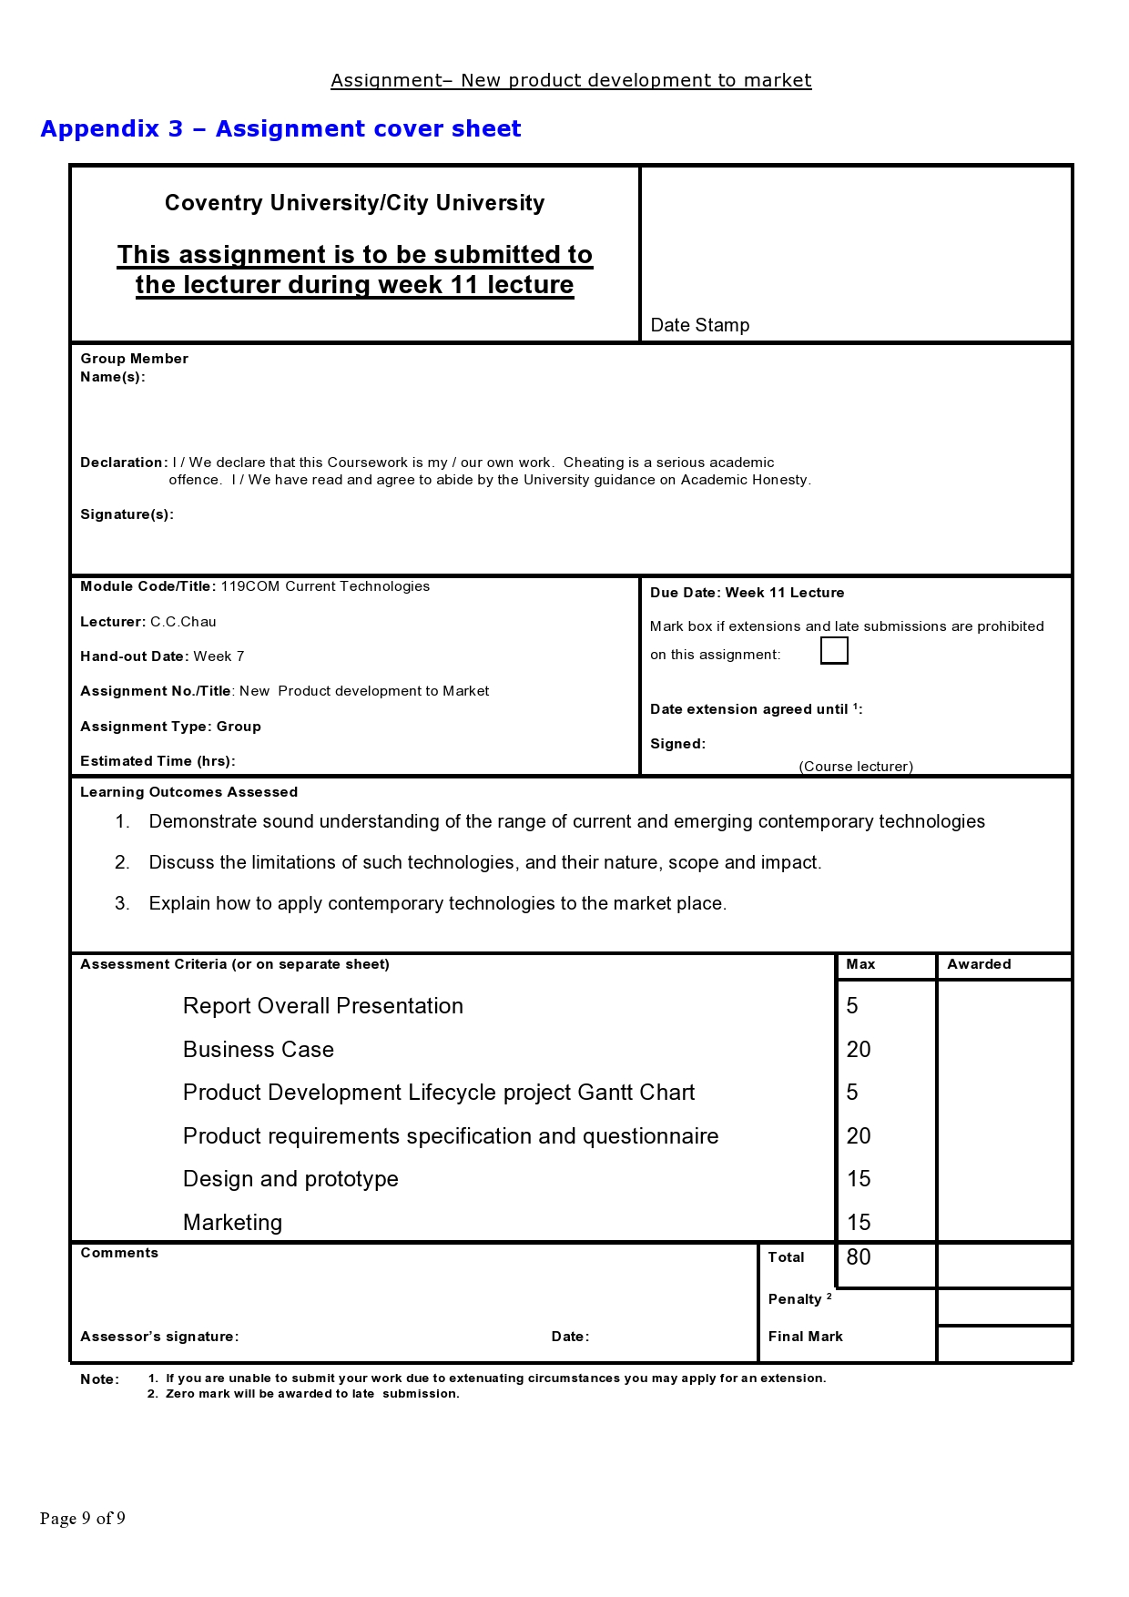

**Module Code and Title: 119COM Current Technologies**

**Assignment Title: Group Assignment**

**New ICT Product Development to Market:**

**Smart Home AI Robot -- Radioactive robot (Robo Alpha, Robo Beta & Robo Gamma)**

**Group Members’ in full names (Student ID):**

**Leung Yuet Hei (55806987)**

**Chan Yik Kit (56237852)**

**Lai Justine (56235545)**

**Lau Tze Cheuk (56235521)**

**Word Count:**

**Table of Contents**

1. **Introduction**
2. **The Business Case**2.1 research and outline of one kind of ICT products   
   2.2 Explain the business opportunities  
   2.3 Collectively decide and choose one  
   2.4 The choice we chose and any other supporting elements
3. **Product Development lifecycle Gantt chart**
4. **Product requirements specification**4.1 Questionnaire to sample of potential users  
   4.2 Survey, pie chart, results and report  
   4.3 Conclusion of above result
5. **Design of prototype**
6. **Conclusion**

**1. Introduction**

Hong Kong is one of the most stressful cities in the world. Everyone works in a fast pace of life. In order to help people to release the intensive pressure, we believe to provide a Dream Home for them to live is essential. No matter you are after work or school, you will feel very relax and comfortable when you return home. Home is our shelter physically and mentally. It is important for everyone.

In this report, we would like to introduce a new product that will help the economy. There are four different products designed by us in the field of smart home. We will choose the most possible and may popular product of the product designs in the four. In the following report, we will analysis the product design we have chosen and find if it is possible to release in the market.

So, why we choose smart home as our topic? As you know, we always stay at out home. It is our comfort zone. It is a place that let you release your stress and relax. In Hong Kong, the house area is small. It may affect citizens emotion. Therefore, we hope that the product we designed can help increase the quality of life.

**2. The Business Case**  
 2.1 research and outline of one kind of ICT products

In Hong Kong, there are over 390,000 domestic helpers (Domestic Helper Hiring Guide in Hong Kong | HelperChoice, 2020). We can see that the demand of domestic helper in Hong Kong is large. So why do the demand of Hongkongers hiring nanny is high and why they want to have a helper? In 2018, the labour force participation rate of married women and men are 49.3% and 68.5% respectively in Hong Kong (2020). There is almost half of women and almost 70% of men that have a family will both go to work. So, they may not have time to take care their children and clean their house. It can release their stress if they have a helper at home. As they do not need worry about the house works.

But there are a few requirements for hiring a maid and so people may not meet the requirements even they want to hire a helper. For example, the employers must provide free medical treatment for their domestic helper and have a suitable accommodation with privacy ((www.gov.hk), 2020). If the employers can not act in concert with the requirement, they cannot hire them. Therefore, the AI robot — Alpha is introduced.

Alpha is a robot that can help you to do house works. Is has humanized muscle structure and a humanized emotion interface that can response you with different emotion. It also can use as a projector. Alpha is control by an app. The AI robot Alpha will help a lot if you do not want to do house works and hire a domestic helper at home.

2.2 Explain the business opportunities

AI Smart Home Puppy Dog (Amy)

When it comes to the smart home, lots of people may think about those hard-working robots likes homework maid robot or the smart housekeeper robot, What my idea pieces pop out in my brain when I think about smart home these days is that: a puppy dog which had the white appearance and it can talks instead of barking, of course not only this function.

In Hong Kong, there are 3.3 million – 44.7% of the population - Hong Kong citizens in 2019 were in living in public rental housing where they are not allowed pet a pet as there is a “Marking Scheme for Estate Management Enforcement” in Public Housing Estates.

Besides, the highlight is not only the product's internal design but the appearance, it is easily imagined that very annoying if there is an AI robot with whole metal external design walking at home. It is suggested that it should be a profitable opportunity for changing the appearance of the smart home product if AI robot puppy dog which got the smart home controlling system but it covered by colored skin and it never barks instead of a metal robot.

AI Smart Home Smart Furnitures (Heidi)

Smart Home technology is to let people feel more comfortable. Smart home furniture, which means the furnitures including chairs, tables and sofas, have tech embedded, which act as one of the important role in providing convenient towards the users. Some of the families may do not have enough space to do gymnastics at home. One of the smart furniture -- Stow Fitness Gym Chair can solve this problem. There is gym equipment being hidden directly under the seat. This kind of smart home furniture with a hidden feature can help space-saving in order to let people workout at home.

In today's rapidly changing world, more advanced technologies have been excavated day by day. It is valuable to have the capability to bring about an at utmost pleasingly and individualism atmosphere within a piece of furniture. Smart home furniture will make further efforts on serving health benefits of relaxation and sleep, plus will let the user taste a staggeringly comfortable motion experience.

Smart lighting can give a profound effect on how comfortable we feel and how well we sleep. With it, you can make a simple adjustment to fulfill your frame of mind for your day-to-day routine. Staying at a proper temperature is also the main element for people to relax or work. Certain aspects of smart home technology definitely permit customers cannot and will not live without.

E-Home (Justine)

Nowadays, we Hongkongers have a rapid pace of life. People are constantly on the go. After you have arrived at your sweet home, you might still have many unfinished works that you have to finish it at home. And you still have to do housework if you do not have a domestic helper. But if you use E-Home, you can save a lot of time as you can control the appliances and electronics by an app. You can set up the time that you want the appliances and electronics to turn on.

For example, you can put the dirty clothes in the washing machine before going out to work. When you almost arrive home, you just need to control the washing machine by the app. You can also prepare your meal by setting up the timer to cook. When you are back, you can simply just hang your clothes and work on other things. It can help you to do multitasking at home and finish it more efficiently and effectively. Also, when the appliances have done its work, it will send a notification to your smart devices that connected to the app.

Also, you do not have to use different remotes to control your electronics at home if you use E-Home. You just need to use the app to help you turn on your television, air conditioner, fan, printer, oven, and the like. E-Home also has a voice control function. I want to develop this app because I want to help the blind and the disabled can be more convenient. Besides the blind and the disabled, it can help people without disabilities a lot too.

AI robot with app interface for home (Angela)

The improvement of artificial intelligence (artificial intelligence) innovation has expanded quickly. The future hints artificial intelligence assume a significant job in the field of wellbeing and life has started to be seen. In certain nations, computer based intelligence is incorporated into refined diagnostic apparatuses to help specialists in emergency clinics analyse malignancy and different sicknesses.

My underlying thought of an item is a developing Artificial Medical Doctor which consequently assists patients with diagnosing infection grumblings online before visiting the specialist. It has a component of understanding the illness design and unravelling the gadget information and afterward detailing the medical issues and private specialists. This artificial intelligence-controlled robot can build the job of specialists, doctors, or medical caretakers and help to uncover subtleties of magnetic resonance imaging (MRI) and other checking machines. The improving artificial intelligence based on discovery strategy and development which offers more prominent precision and recognition effectiveness and can be utilized at a generally minimal effort in a workplace with the most elevated danger of illness.

In the zone of wellbeing, the Artificial Medical Doctor can be utilized from various perspectives, for example, mechanical medical procedure, foresee early malignant growth and back torment, and wellbeing observing. Most importantly, the automated specialist can dissect somebody's chaotic record information before carrying out the activity at that moment. It will manage and direct the specialist during the activity procedure. Likewise, the utilization of this robot can deliver new careful strategies through information from past activities to quicken and streamline the activity procedure. Besides, every patient will be given a smartwatch to distinguish their pulse and action for intently wellbeing checking. The smartwatch can record client propensities data which can be a reference of information for specialists if the casualty is debilitated.

2.3 Collectively decide and choose one

AI Smart Home Puppy Dog (Amy)

Pros:

1. User friendly as the lovely appearance
2. Provide more functions
3. Better customer experience as the personalized service

Cons:

1. Higher Cost when operating the product
2. It is difficult to manage
3. Need to decide how to promote it
4. Need to research of the related law

AI Smart Home Smart Furniture (Heidi)

Pros:

1. Space-saving
2. Easy to assemble them in just a few minutes
3. It is environmentally friendly that air conditioning and lighting can be controlled for optimal energy efficiency.

Cons:

1. Expensive
2. Hard to repair by handy people, professionals are needed

E-Home (Justine)

Pros:

1. Make your life more convenient
2. Feel more comfortably as it has notification to remind you
3. User friendly interface

Cons:

1. You have to use the appliances and electronics that supported by E-Home

AI robot with app interface for home (Angela)

Pros:

1. Decreases the complexities and blunders brought about by human carelessness that can happen during medical procedure and makes the patients remain shorter in the emergency clinic
2. Bolster different parts of the wellbeing area and turns out to be a significant jump which can deliver counteraction procedures and treatment that are considerably more proficient and powerful, including decreasing the expense of clinical consideration
3. The ease and abilities of machine seem to be progressively alluring as to improve tolerant consideration and security
4. 24/7 working hours without any rest therefore this can minimize doctor and nurses’ workload

Cons:

1. Can't supplant the job of specialists in decision making
2. Patient's protection issues in the wellbeing framework
3. Cost adequacy → a costly investment in new human services innovation

The final idea we choose : AI robot with app interface for home -- (Robo)

2.4 The choice we chose and any other supporting elements

(market condition, user requirements, competitions, skills available, benefits)  
Among the four products, we choose the AI robot with app interface at home — Robo as our final decision. Robo is designed to help to do cleaning and house works. It has humanized muscle structure that can just walk and run like us and can get emotional response. So, how it is works? In its brain, it contains a hardware to store worldwide information, and it could learn new things by itself. Robo is connected by wi-fi and you could control it by the app. For a robot with 1.8m height, it is necessary to have a cooler to prevent overheat. Therefore, there is a cooler in its body to adjust Robo internal temperature. Also, for the charging of Robo. We designed to use solar energy. It can help the master of the robot to reduce the expenditure for Robo and it is more environmental-friendly to our earth. To absorb the solar energy, there are solar panel in its back for battery charging. It could store the solar energy in its battery. So, you can let Robo to help even it is cloudy.

Robo is mainly designed for people who want to hire a domestic helper but not meet the requirement and for people that he or she do not want to have a stranger at home. To hair a domestic helper, the monthly minimum allowable wage is $4630 ((www.gov.hk), 2020). And you will need $55560 a year to hair a maid. For out AI robot, the price range is $50000 to $70000, and it could use up to 10 years. The price for Robo is just around $5000 to $7000 a year. People who cannot afford the price for a helper can buy Robo for help. Robo would not occupy many spaces in your home, you do not need to provide a room and food for Alpha. All you need to do is maintenance Robo in good condition.

For people who are interested in Robo, do not need to worry if it is hard to use. We use user friendly app interface. You can control it easily. In the app, it will show you the battery Robo left and will have notification to remind you. Also, there is a recording button for you to command Robo and chat with Robo. And we will update Robo and there will be new product in future. So, you can have the best experiment on use Robo.

**3. Product Development lifecycle Gantt chart**

**The Lifecycle Gantt Chart of Smart Home AI Robto -- Robo**

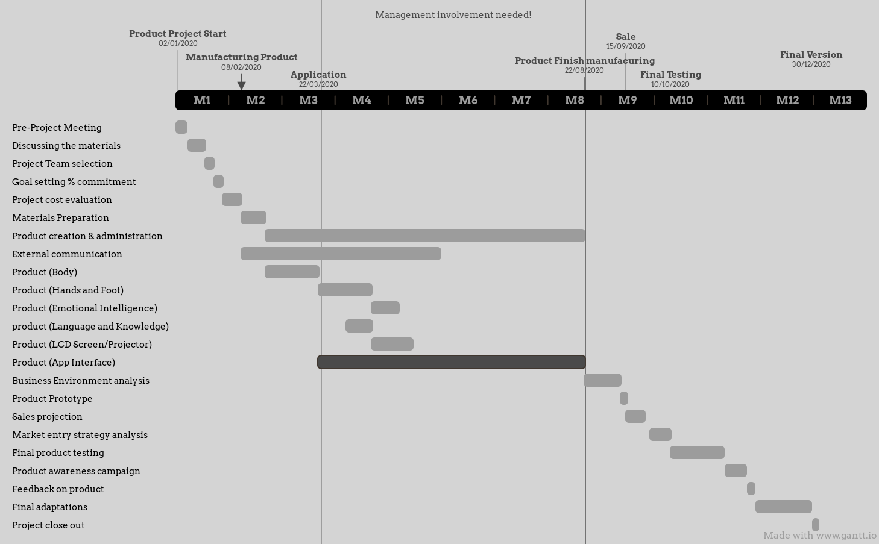

3.1 Project plan (a Gantt chart)

The above Gantt chart is showing the time log and the lifecycle of our new product-Robo. There are a total of 12 months in duration, set the above Gantt chart start from 1st of January 2020 to 31st of December 2020. It can certainly look like four parts: preparation work, manufacturing work, business, and testing to improve.

The first part is about the preparation work, starting from Pro-Projecting Meeting to Materials Preparation which lasts for two months. It includes the prediction of cost usage and amount, searching the right materials, and select suitable professional team members for operating Robo.

The second part mainly working on manufacturing, both parts of the body, hands, and feet last for 1 month. After that, a half month for inserting the data of emotional intelligence and another half month for inserting the language and knowledge data. Then there is the LCD screen setting and making the App that needs about 3 months on both of them. This part lasts for half a year.

The next part is working on the business, the product is ready for sale so there should have time for business analysis for the new product. Create the sales projection and market entry strategy analysis though the prepared product prototype to know the highlight of the new product, for example, Robo is suitable for all ages to use in the home, maybe it can collaborate with some IT companies and government. This is going to take for 2 months and a few days.

The final part is focusing on testing and improvement, keep testing Robo and feedbacks on it should help a lot for upgrading the product and collecting the opinions from the user. Making progress on Robo and decide the final model for sale in the future. It is decided last for almost 2 months or more.

At the end of project planning, it is going to say that no one can predict will it work or become very popular but it is got enough time as it is going to put about a year to work on it, therefore it is worthy to try though following this Gantt chart.

**4. Product requirements specification**

4.1 Questionnaire to sample of potential users

**New ICT Product Development to Market: Smart Home AI Robot -- Radioactive robot ( Robo Alpha, Beta, Gamma )**

Hello!

We are students from the City University of Hong Kong. The purpose of this questionnaire is to let us have further clarification, enhance, and refine our list conduct the following: Analyse the market place and determine the target audience. We have designed a radioactive robot in 3 different sizes ( Big size, Medium size & Mini size ). I hope you can take 3 minutes to help complete this questionnaire!

The information obtained from this questionnaire is strictly confidential for research and analysis and destroyed after study.

Please feel free to fill in.

Gender *

Male

Female

Age group *

4-12

13-18

19-24

25-39

40-64

65 or above

Do you live with children or the elderly? *

Children

The elderly

Both children & the elderly

None of the above

Different sizes & color of our radioactive robot

Our product -- Radioactive Robot can be made in different sizes. Which size would you want to choose? *

Big size ( 1.8 m tall )

Medium size ( 1 m tall )

Mini size ( 60 cm tall )

The design of the robot's outer shell is made by oxidation-resisting steel (Silver in colour), its muscles will be seen. What kind of colour do you want the robot to be? (Only muscles, eyes and tongue can change their colour) *

Golden

Blue-green

Orange-red

Bright green

Others：

The following 3 questions are about how satisfied are you with those functions in 3 different sizes respectively.

Suggestions are welcomed for the further room for improvement of our product.

Our big size robot -- Robo Alpha can carry heavy stuff, mainly do furniture cleaning & do housework. *

Very disagree

Disagree

General

Agree

Very agree

Others：

Our medium size robot -- Robo Beta can do delivery service, take care of the elderly & do housework. *

Very disagree

Disagree

General

Agree

Very agree

Others：

Our mini size robot -- Robo Gamma can irritate the plants & take care of children. *

Very disagree

Disagree

General

Agree

Very agree

Others：

Your thought about our product

Our robot's eyes can project the thing that the user wants to present which acts as a projector. What do you think? *

Useful

Not useful

An app has been created for the user to easily control the robot and personalize information. What do you think? *

Useful

Not useful

Our aim is to create a friendly design for the elderly and disabled person, also for better user experience. Will you support us? *

Yes

No

Neutral

You have been completed the questionnaire. Thank you for your time!

4.2 Survey, pie chart, results and report

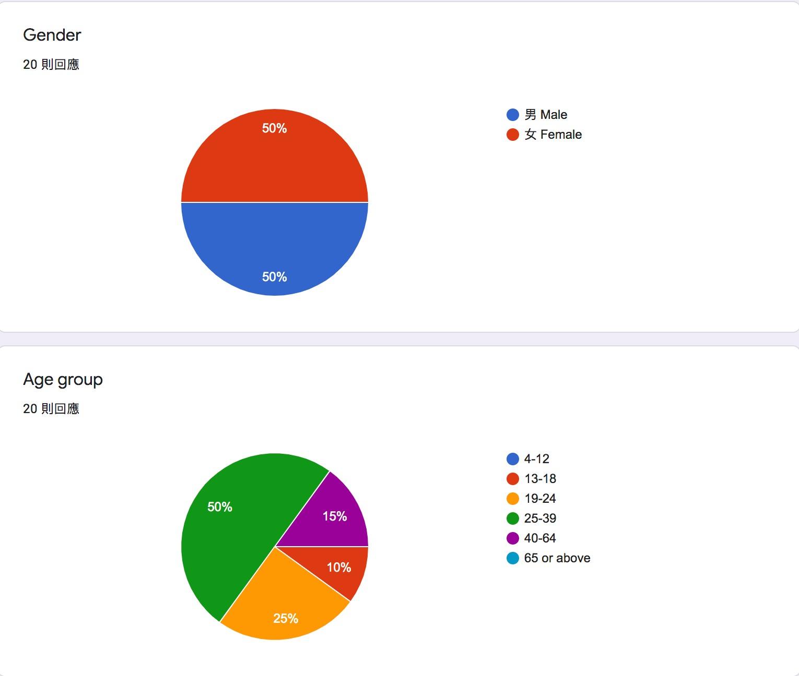

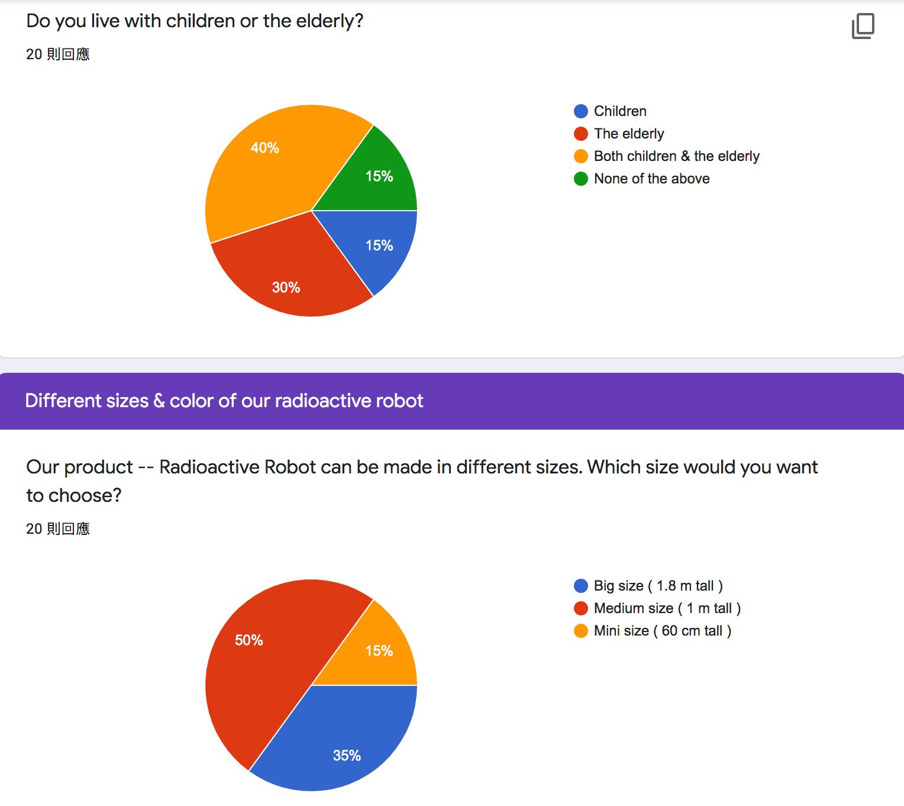

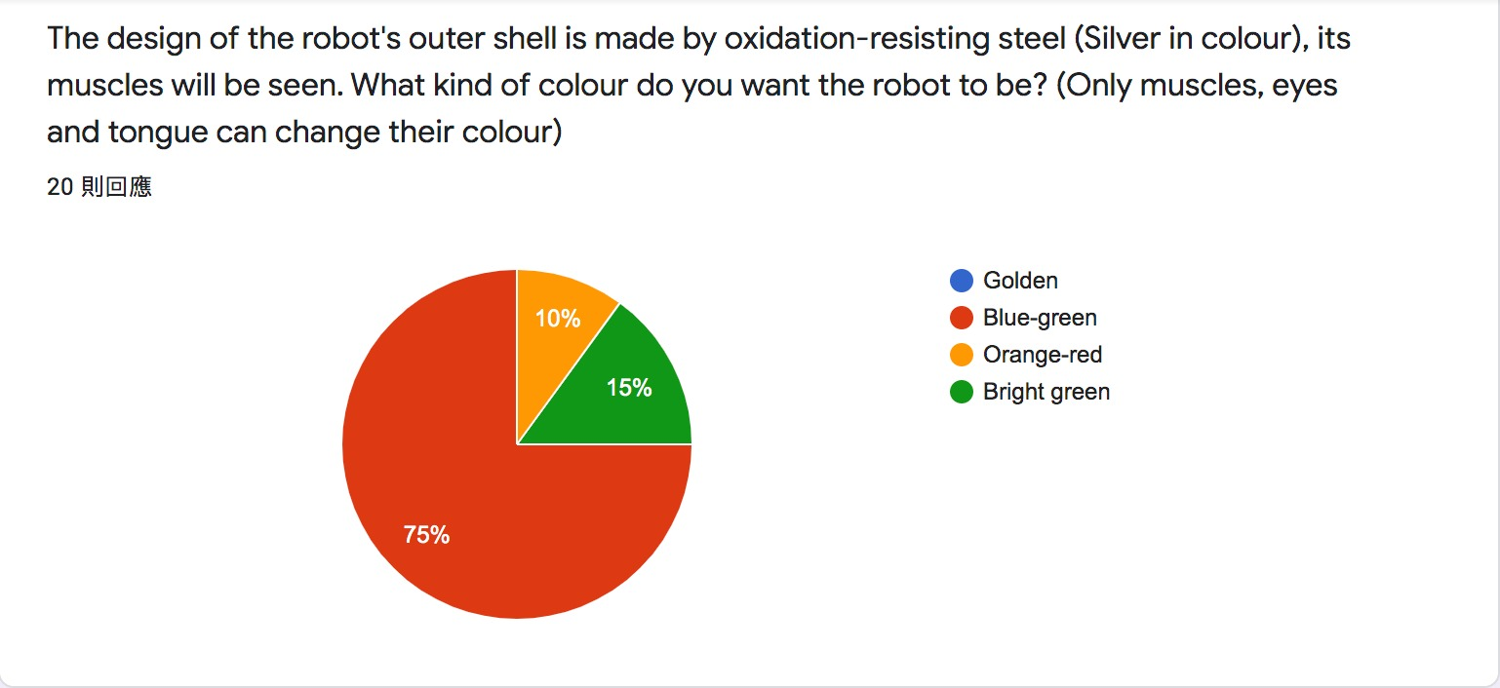

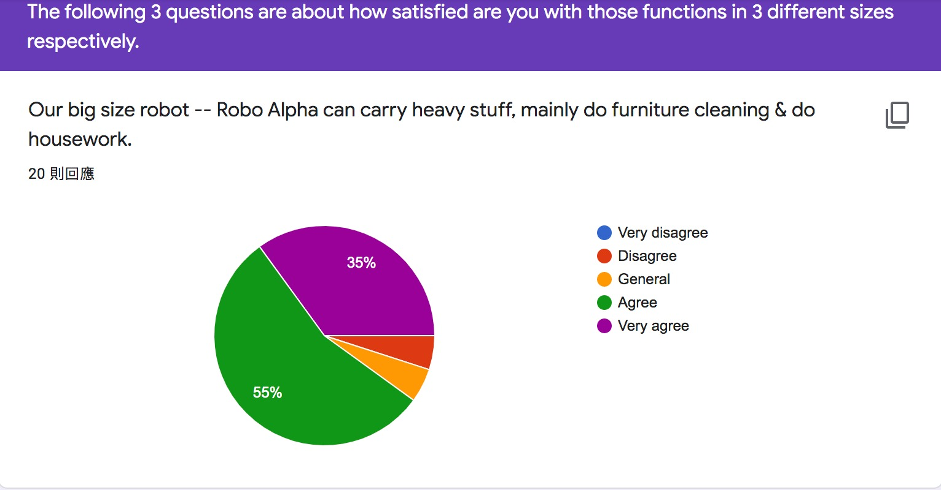

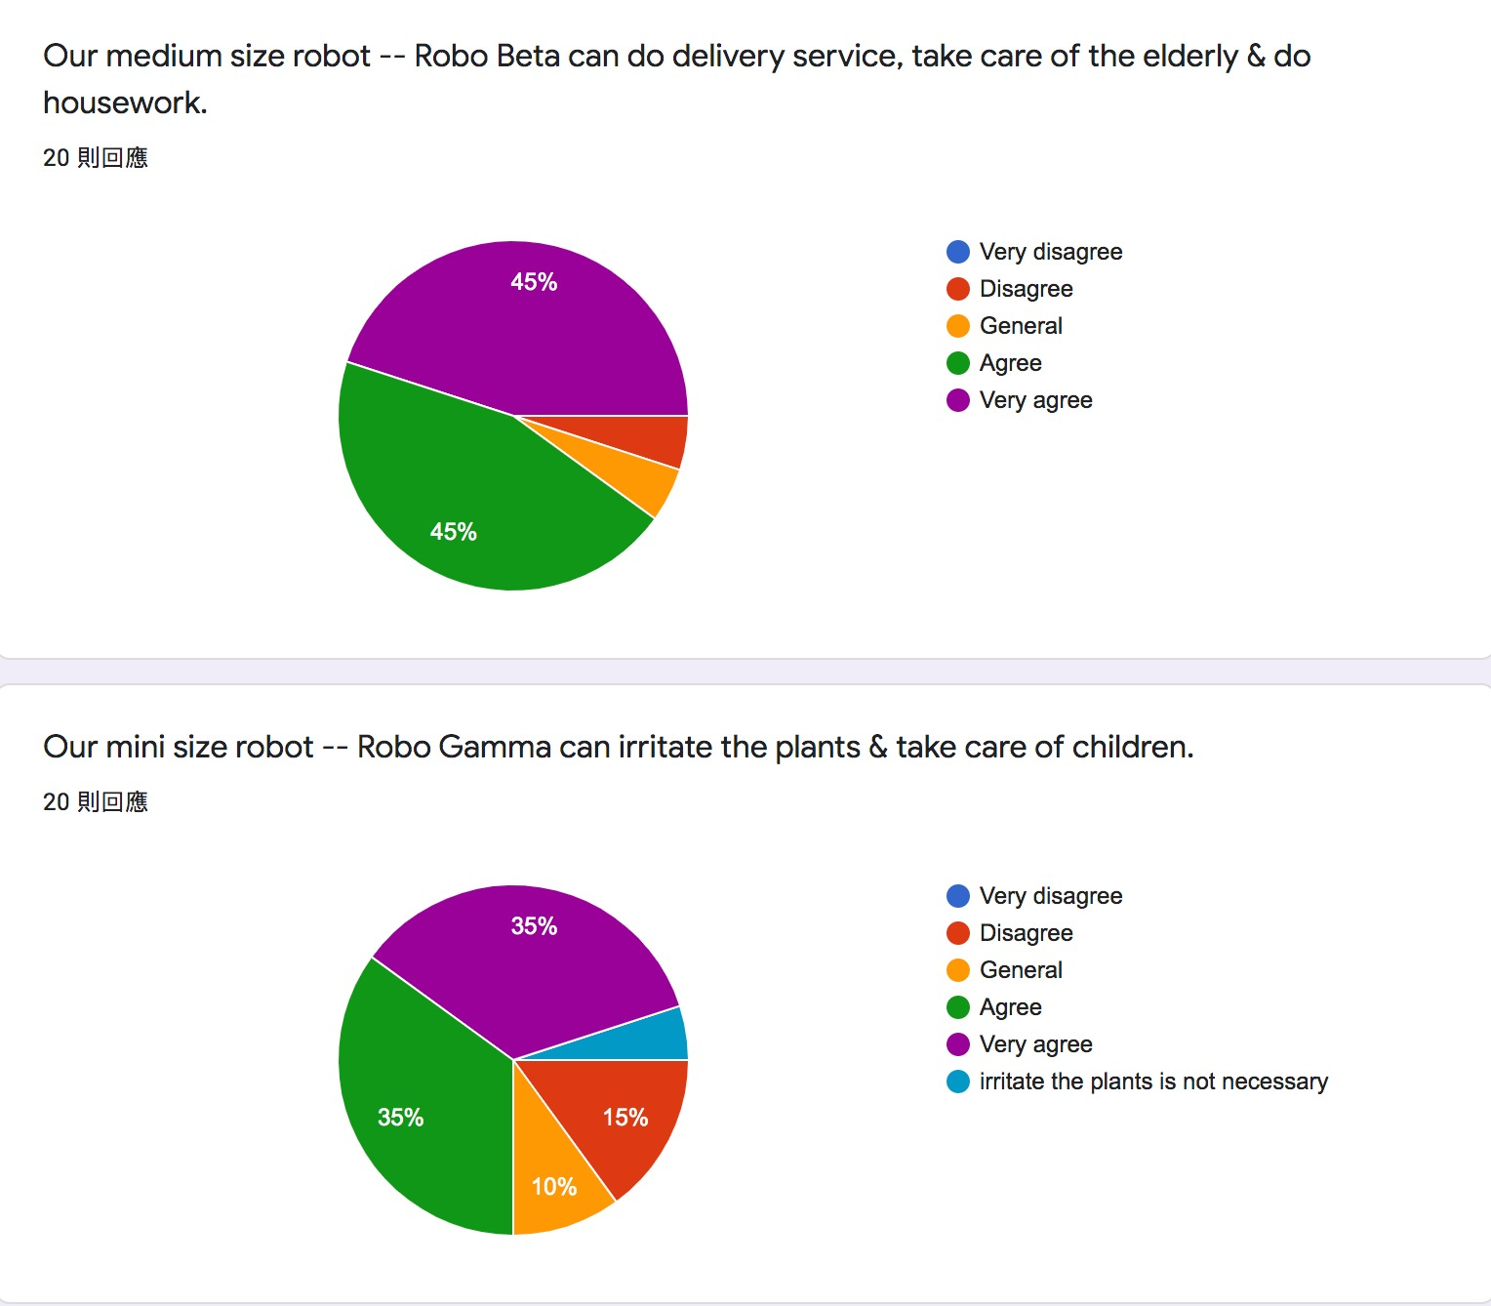

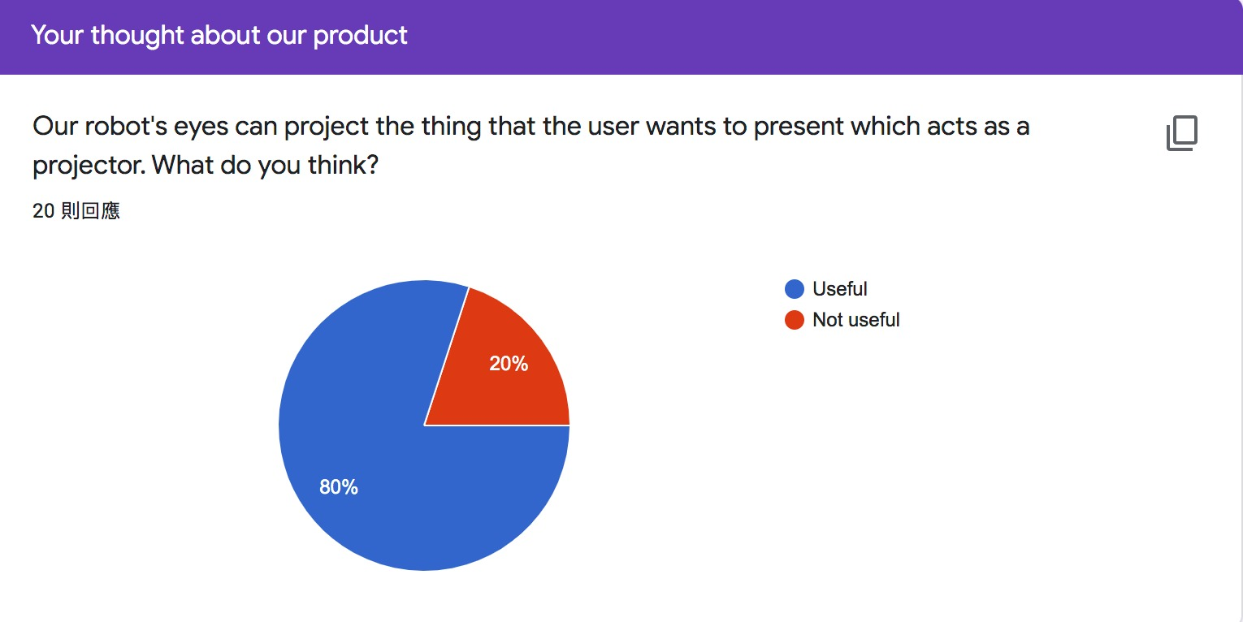

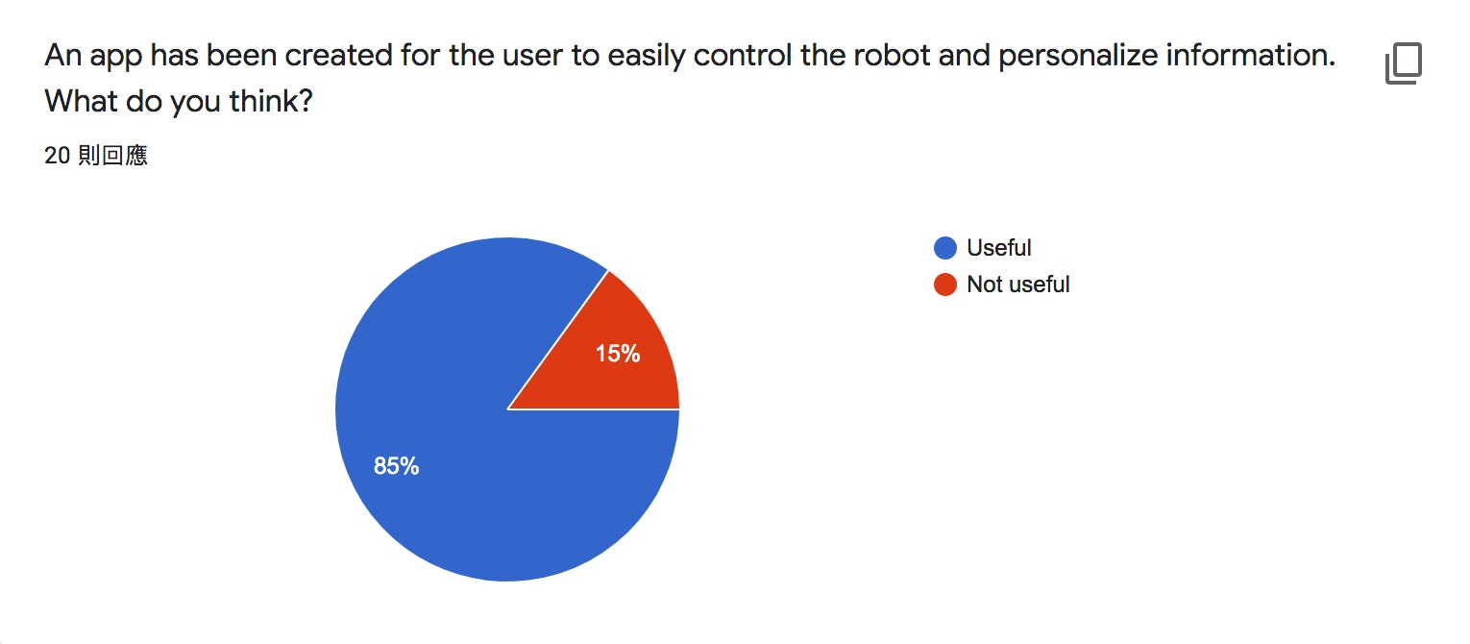

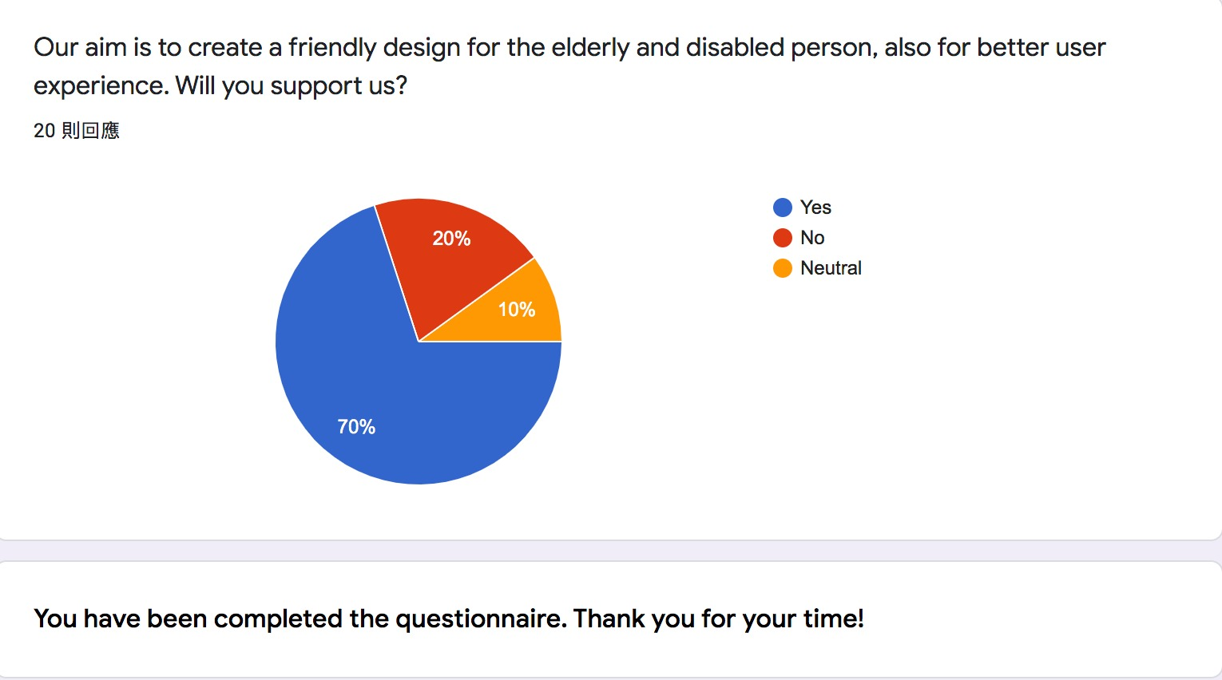

4.3 Conclusion of above result

We have invited 10 females and 10 men to do our questionnaire. Half of them are in the 25-39 age group. 40% of them live with both children and the elderly, while 30% of them live with the elderly. There are 50% (10 people) would like to choose the medium size of our radioactive robot. Blue-green is the most popular robot colour among them. The functions of all sizes of the robot are good. But for the mini size – Robo Gamma, there is some disagreement inside that there is a candidate who responded that the function of irritating the plants was not necessary. 80% of them thought that our robot’s eyes act as a projector is a good idea. 85% of the candidates thought that the idea of creating an app for further adjustment of the robot can easily control. Almost three-quarters of people supported our aim to develop our robot market.

**5. Design of prototype**   
 5.1 Physical appearance  
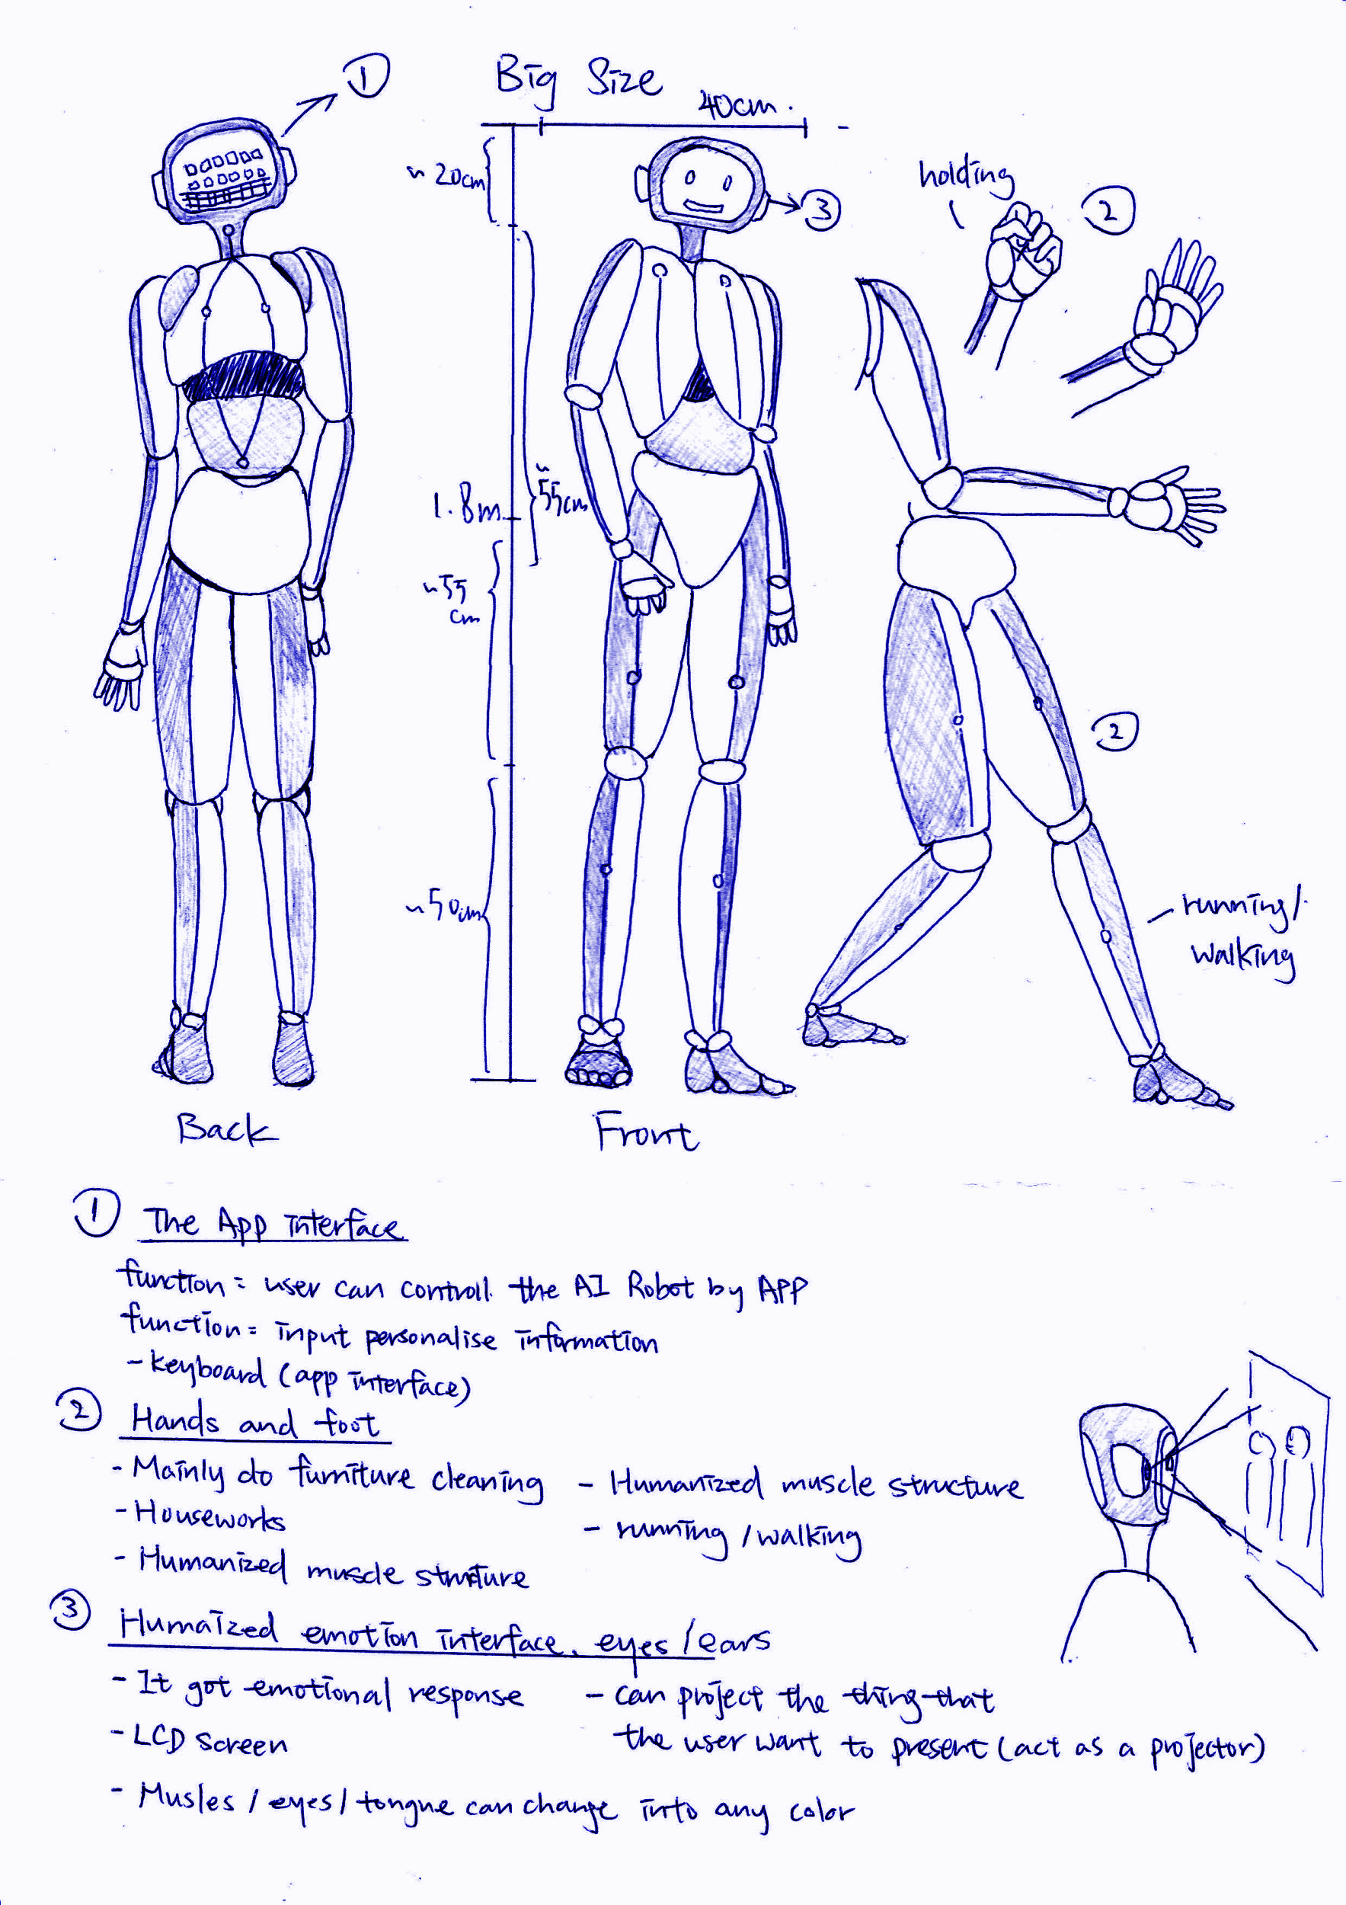

Brain

– Contains a hardware to store worldwide information

– Learn knowledge in every moment

– Always connect to Wi-Fi

Back

– Equipped with

* Solar panel → for battery charging
* Cooler → to adjust its internal temperature

5.2 The underlying technology

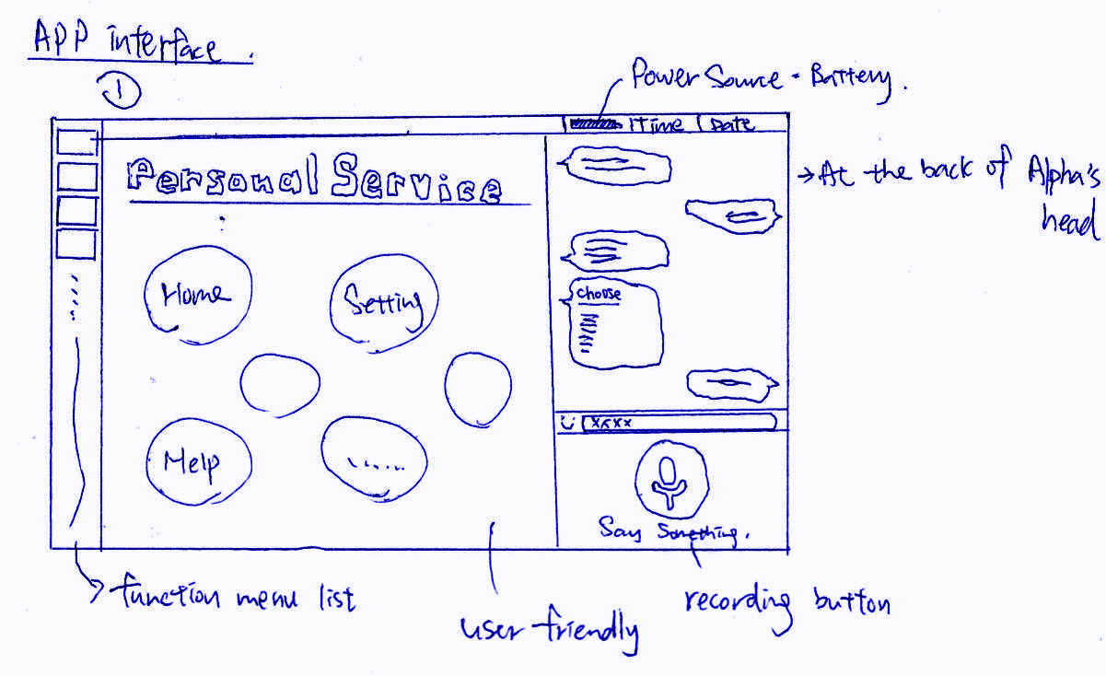

5.3 interface designs

The brain of the robot contains a hardware to store worldwide information, learn knowledge in every moment. It always connect to Wifi. The robot muscles are made by HASEL actuators in order to keep strong and flexible at the same time. The outer casing is made by oxidation-resisting steel in order to protect itself.

**6. Marketing**   
 6.1 Situation Analysis

There are four parts through using the SWOT format which includes strengths, weaknesses, opportunities, threats, and target audience, to analyze the situation of our new product -- Robo.

First of all, Robo is strength at it is personalized, you need to input what you want it to look like and what you wish it can do like housework, look after elderly and children, etc. In addition, it got three different sizes, it is called Robo Alpha for the big size, Robo Beta for the medium size, and Robo Gamma for the smallest size. They can do some things but with different sizes, as what the customer likes to use. Robo Alpha and Robo Beta are good at housework or doing some motion which needs to holding heavier stuff. Robo Gamma can play with children as it is a smaller and similar height with the child. Those are the example of what they can do. Moreover, Robo can control the application and user-friendly interface. It also got the humanized voice and emotional response for the user which is a friendly design for the elderly and disabled person, also for better user experience. Therefore, it got wide usage and improve the quality of human daily life. These all will be an attractive point for Robo.

Besides, Robo got a disadvantage is that it uses quite a lot of electric power which means it needs a long time for charging. However, it is fair and bidirectional as it can work for a long time after charging. It is worried this point may reduce part of customers and profit. Moreover, Robo can not speak very naturally and 100% like a human because it is only spoken as similar as possible with the human. Plus, the selling price will be expensive as the materials of the Robo certainly cost not cheap. This will reduce part of the customers and profit. These are all need to improve in the future.

Apart from the strength and weaknesses of Robo, we believe it got profitable opportunities and development opportunities. Robo can be used to look after the elderly, children, and disabled people which includes our target customers. Anyone can use it, no matter just as a housekeeper or buddies, Robo will help life becoming more innovative. Nevertheless, someone may doubt that it may bring threats of the (elderly care workers and children) caring industry as it may replace them. Actually, it can say that it is impossible to happen but it is sure that it will not happen nowadays because nothing can replace human love and warmth so do not need to worry about this point. In the foreseeable future, it is believed that more improvement will be going to do after testing and collecting feedback from users.

6.2 Marketing Strategy

Our mission statement is that we are committed to the development of a new era of science and technology, making progress in the quality of human life, and then increasing the scope of technology use. Robo will become one of the big steps, gradually integrating technology products into human life and facilitating humanity. Making contributes to the next generation.

We aim to improve the inconvenience in human daily life, especially at home. AI Robot -- Robo (Alpha, Beta, and Gamma) will be a fresh and useful product for people, especially people in need and alone, Robo can help for your housework and stay with you, he will be a good housekeeper and your personal buddies.

First, it is decided to join more exhibitions to push popularity and attracting customers, becoming more and more famous to build the brand and also doing some collaboration event. If Robo can collaborate with the government, widen it for all citizens, it will change the generation and human life experience and quality. Generally speaking, there not many people now using AI in-home, that is the reason for better to do a collaboration with organizations, companies, or even government. Robo is focused on the AI smart home industry which already got a variety of masterpieces, therefore we are going to be mainly for housework and caring person in need. Since it got the demands, it will get the market.

**7. Conclusion**

Last but not least, robots are totally consistent and don't contain code to feel sympathy. In this regard, human capacities have far effort to those PCs. Artificial intelligence is intensely dependent on rationale, as everything in its code is simple which permits it to work with less mistake. While this rationale licenses PCs outperform human capacities in specific practices, it limits robots associating on an individual level. Moreover, it compels PCs' capacities to face determined challenges and to save human life, rather than making them subject to what the consistency and most precise choice ought to be. In specific cases, this could imply that the PC doesn't endeavour to rescue a patient's life, though a specialist would do as much as possible to protect the life.

While there are numerous contentions to the usage of innovation, there are countless points of interest to counter them. Since several human weaknesses don't influence machines, robots will have the option to supplement people by helping a portion of the deformities. By considering to improve its skill, upgraded and progressively educated determinations, and advanced tele-instruction, an observed coordination of innovation. As long as computerized reasoning is utilized to advance the abilities of human specialists and not to supplant them, their reception and headways look well for the future clinical innovation.

APPENDIX 1

LOG OF OUR CONTRIBUTIONS AND WORK

Introduction (Justine)

Business case (a), (c) and (d) (Justine+ All)

Gantt chart (Amy)

Questionnaire, pie chart and survey report (Heidi, & Angela)

Product Appearance design (Heidi & Amy)

Marketing (Amy & Angela)

Conclusion (Angela)

APPENDIX 2

Reference List

1. Builders in Calicut | Apartments for Sale in Kozhikode | Flats in Calicut. 2020. *How Do Smart Homes Work?Advantages And Disadvantages Of Smart Homes*. [online] Available at: <https://pvsbuilders.com/advantages-and-disadvantages-smart-homes/> [Accessed 15 May 2020]..

1. Consumerreports.org. 2020. *Best Home Automation System - Consumer Reports*. [online] Available at: <https://www.consumerreports.org/cro/magazine/2014/06/run-your-home-from-your-phone/index.htm> [Accessed 12 May 2020].

1. Gadget Flow. 2019. *You Won’t Believe What This Smart Home Furniture Can Do*. [online] Available at: <https://thegadgetflow.com/blog/you-wont-believe-what-this-smart-home-furniture-can-do/> [Accessed 13 May 2020].

4. HelperChoice. 2020. *Domestic Helper Hiring Guide In Hong Kong | Helperchoice*. [online] Available at: <https://www.helperchoice.com/hong-kong> [Accessed 10 May 2020].

5. Housingauthority.gov.hk. 2020. *Allocation_Status*. [online] Available at: <https://www.housingauthority.gov.hk/en/public-housing/estate-management/marking-scheme-for-estate-management-enforcement/index.html> [Accessed 8 May 2020].

6. McIntosh, A., 2020. *Smart Home Technology And A Healthy Lifestyle | Furniture Lighting & Decor*. [online] Furniturelightingdecor.com. Available at: <https://www.furniturelightingdecor.com/smart-home-technology-and-healthy-lifestyle> [Accessed 13 May 2020].

7. South China Morning Post. 2020. *Why Public Housing Shortfall Will Remain A Thorn In Hong Kong’S Side*. [online] Available at: <https://www.scmp.com/news/hong-kong/society/article/2182106/why-public-housing-shortfall-will-remain-thorn-hong-kongs> [Accessed 13 May 2020].

8. Statistics.gov.hk. 2020. [online] Available at: <https://www.statistics.gov.hk/pub/B11303032019AN19B0100.pdf> [Accessed 10 May 2020].

9. (www.gov.hk), G., 2020. *Govhk: Hiring Foreign Domestic Helpers*. [online] Gov.hk. Available at: <https://www.gov.hk/en/residents/employment/recruitment/foreigndomestichelper.htm> [Accessed 10 May 2020].